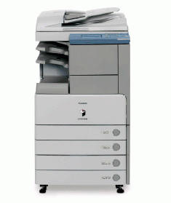

**iR 2870**

* Operating at 28 pages-per-minute, the imageRUNNER 2870 is equipped with a standard memory of 256 MB and an optional 20GB Hard Disk Drive to provide users with exceptional productivity and reliability
* With a scanning resolution of 600 x 600 dpi, enhanced copy resolution of 1200 x 600 dpi, and enhanced print resolution of 2400 x 600 dpi, the imageRUNNER 2870 delivers superior quality for the most faithful reproduction of text and images
* The touchscreen user interface panel and intuitively-designed device drivers provide user-friendly operation for both walk-up and desktop environments
* Compact, space-saving design .
* Designed with Canon's RAPID Fusing Technology to significantly reduce energy consumption and improve productivity
* An optional 50-sheet capacity Duplexing Automatic Document Feeder makes quick work of scanning multi-page and different-size originals
* With a standard paper capacity of 1,150 sheets, which can be expanded to 2,250 sheets, the imageRUNNER 2870 has been designed to meet the volume requirements of any workgroup .
* Network printing to provide maximum flexibility and performance for busy corporate workgroups and departments .